LAB

REPORT

CSE 114 : Data Structure and Algorithms Sessional

|  |  |
| --- | --- |
| PREPARED BY  Mehrin Farzana  ID: 2101013  Session: 2021-2022  Date: 09/08/2023 | SUPERVISED BY  Suman Saha  Lecturer  Department of IRE, BDU |

|  |  |
| --- | --- |
| logo1 | BANGABANDHU SHEIKH MUJIBUR RAHMAN DIGITAL UNIVERSITY  (BDU) |
|  |  |

**List of Problems**

1. Given the following-

• A knapsack (kind of shoulder bag) with limited weight capacity.

• Few items each having some weight and value.

The problem states,

Which items should be placed into the knapsack such that-

• The value or profit obtained by putting the items into the knapsack is maximum.

• And the weight limit of the knapsack does not exceed.

• Either take the item or leave it whole.

1. Given two string, find the longest sub sequence.

**Problem No.:** 01

**Problem Statement:**

Given the following-

• A knapsack (kind of shoulder bag) with limited weight capacity.

• Few items each having some weight and value.

The problem states,

Which items should be placed into the knapsack such that-

• The value or profit obtained by putting the items into the knapsack is maximum.

• And the weight limit of the knapsack does not exceed.

• Either take the item or leave it whole.

**Code:**

#include <stdio.h>

int max(int a, int b){

if(a>=b)

return a;

else

return b;

}

int main()

{

printf("Enter number of items & knapsack capacity: ");

int n,C,k=0;

scanf("%d%d", &n, &C);

int w[n], v[n], o[n];

int p[n+1][C+1];

printf("Enter weight: ");

for(int i=0; i<n; i++)

scanf("%d", &w[i]);

printf("Enter value: ");

for(int i=0; i<n; i++)

scanf("%d", &v[i]);

for(int i=0; i<=n; i++){

for(int j=0; j<=C; j++){

if(i==0 || j==0){

p[i][j]=0;

}

else if(j-w[i-1]>=0){

p[i][j]=max(p[i-1][j], v[i-1]+p[i-1][j-w[i-1]]);

}

else if(j-w[i-1]<0){

p[i][j]=max(p[i-1][j],p[i][j-1]);

}

}

}

printf("Max profit: %d\n", p[n][C]);

for(int i=n, j=C; i>0; i--){

if(p[i][j]!=p[i-1][j]){

o[k]=i;

j-=w[i-1];

k++;

}

}

printf("Items included: ");

for(int i=k-1; i>=0; i--)

printf("%d ", o[i]);

return 0;

}

**Output:**

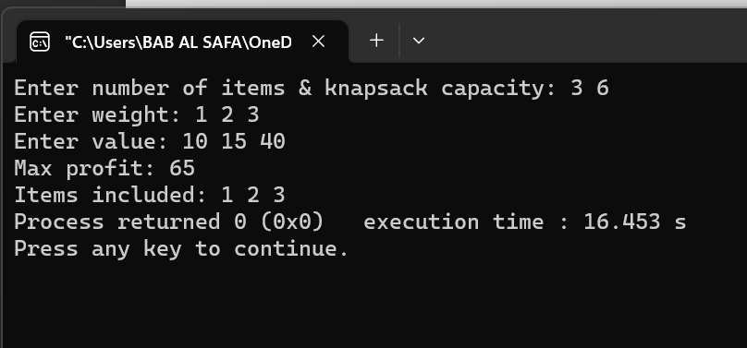

Fig 1.1: Output on console for case 1.

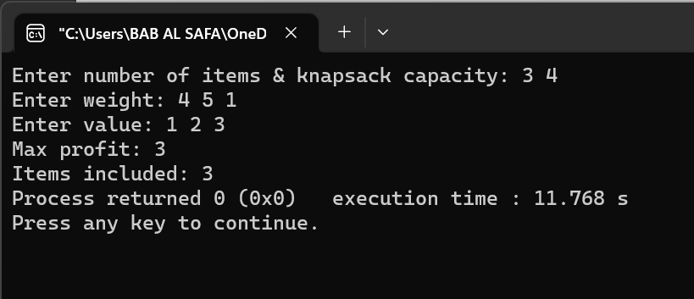

Fig 1.2: Output on console for case 2.

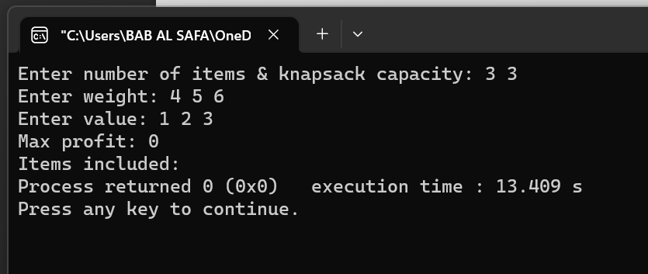

Fig 1.3: Output on console for case 3.

**Problem No.:** 02

**Problem Statement:**

Given two string, find the longest sub sequence.

**Code:**

#include <stdio.h>

int main()

{

char t1[101], t2[101];

scanf("%s %s", t1, t2);

int n1=strlen(t1)+1;

int n2=strlen(t2)+1;

int c[n1][n2];

char b[n1][n2];

for(int i=0; i<n1; i++){

for(int j=0; j<n2; j++){

if(i==0 || j==0){

c[i][j]=0;

}

}

}

for(int i=1; i<n1; i++){

for(int j=1; j<n2; j++){

if(t1[i-1]==t2[j-1]){

c[i][j]=c[i-1][j-1]+1;

b[i][j]='*';

}

else if(c[i-1][j]>=c[i][j-1]){

c[i][j]=c[i-1][j];

b[i][j]='^';

}

else{

c[i][j]=c[i][j-1];

b[i][j]='<';

}

}

}

printf("%d\n", c[n1-1][n2-1]);

int n;

n1--;

n2--;

if(n1>=n2)

n=n2;

else

n=n1;

char lcs[n];

for(int i=0; n1>0 && n2>0; ){

if(b[n1][n2]=='*'){

lcs[i]=t1[n1-1];

n1--;

n2--;

i++;

}

else if(b[n1][n2]=='<'){

n2--;

}

else if(b[n1][n2]=='^'){

n1--;

}

}

for(int i=n-1; i>=0; i--)

if(lcs[i]!='\0')

printf("%c", lcs[i]);

return 0;

}

**Output:**

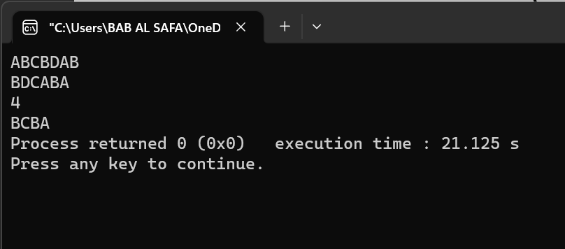

Fig 1.1: Output on console for case 1.

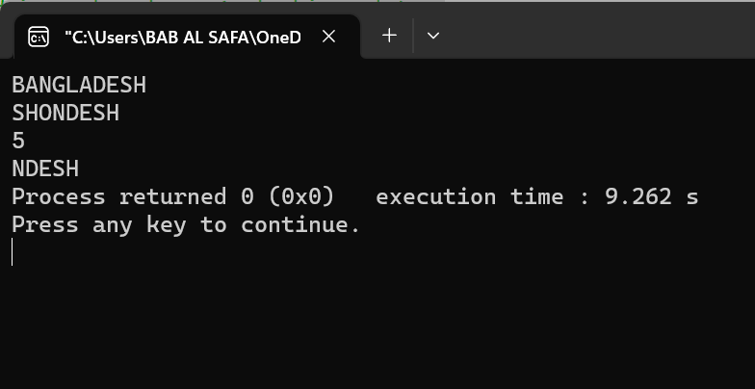

Fig 1.2: Output on console for case 2.

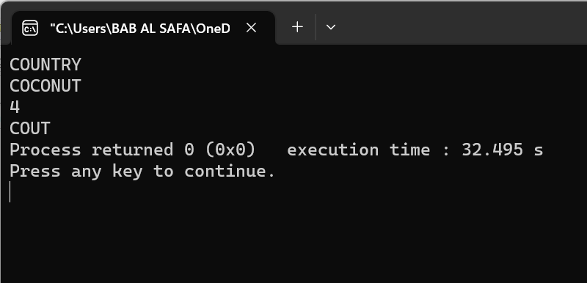

Fig 1.3: Output on console for case 3.